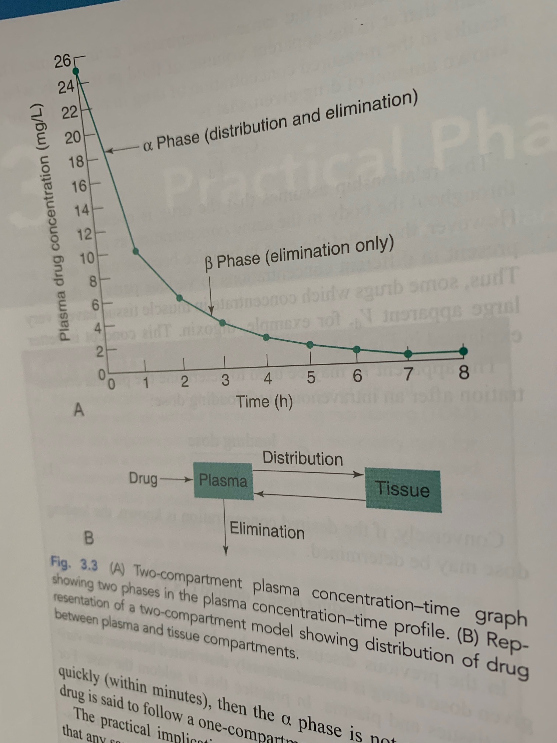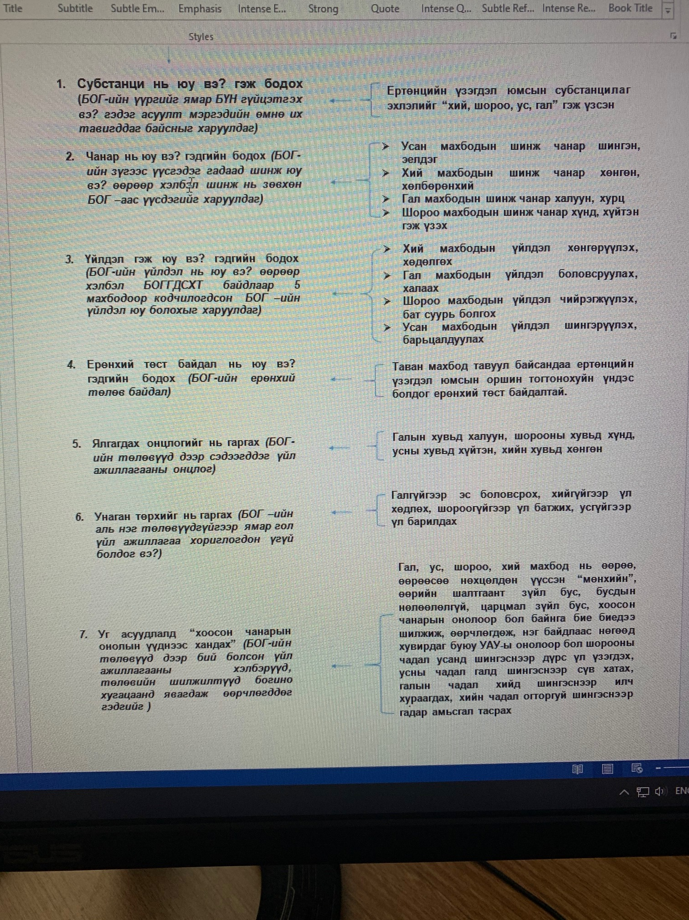Нэгдүгээр санаа :
https://study.com/academy/lesson/amphoteric-definition-properties-examples.html

NCM анагаах ухааны үүднээс хамгийн сонирхолтой эмийн хэлбэр бол амфотерик - amphoteric хэлбэр бөгөөд ийм хэлбрийн эмэнд өөрөөсөө электрон- протоныг чөлөөлж исэлдсэн хэлбэрт нэгдэлд өгдөг хүчиллэг бүлэг ч агуулагддаг , мөн өөр ангижирсан нэгдлээс электрон - протоныг авдаг шүлтлэг бүлэг ч агуулагддаг, “Донатор + мембран - редокси потенциалын гурван төлөвт шугам + О₂ + АДФ + Pi + H⁺ + nH⁺_{memb.space} = (ATP + дулааны энерги) + Н₂О + nH⁺_{matrix} + СО₂” тэгшитгэл ба протоны урсгалын 9 дамжлагат хэлхээний “доторхи гурван фаз бүхий Мембран- редокси потенциалын гурван төлөвт шугам дээр альфа төлөв, бетта төлвийн дунд орших гамма төлөв дээр үйлдлээ голлон үзүүлдэг , ийм байдлаараа УАУ-д“ хийгээр“кодлогдсон өвчний үед үйлдлээ үзүүлдэг эмийн хэлбэр байж болох бөгөөд ийм биологийн идэвхит нэгдлүүд бол УАУ- ы талх эмэнд ихээр агуулагдаг байх боломжтой( тан эм бол water soluble) тосонд уусдаг, усанд уусдаг аль чанартай бүлгүүд агуулдаг учраас нэг хэсэг нь ходоодны рН орчноос ( энд fat soluble эмүүд абсорбцид голлон ордог) шимэгддэг ( рН оf solution: Pka of Drug харьцаа гэсэн ойлголтын үүднээс) байхад зарим хэсэг нь нарийн гэдэснээс шимэгддэг- абсорбцид ордог ( энд water soluble эмүүд абсорбцид голлон ордог) нь ийм дүгнэлт хийх боломжийг өгдөг, бид ийм судалгааг явуулж эхэлж байна.
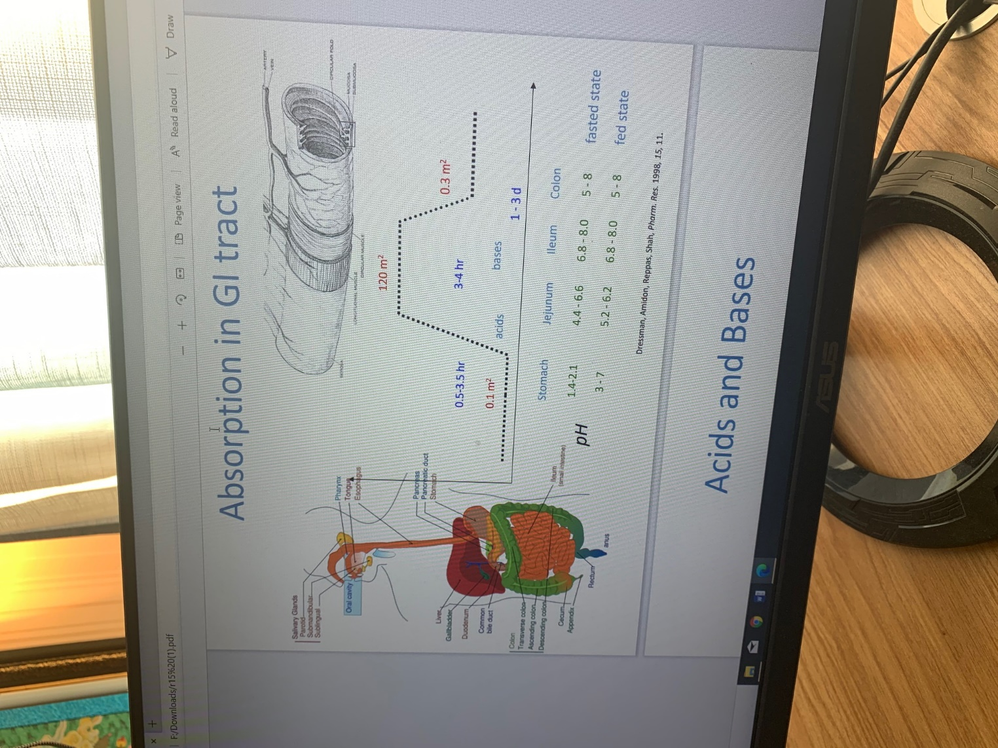

Amphoteric: Definition and Properties – УАУ-ы Талх эм
When you think of amphoteric substances, think of a dual-purpose product that we can buy in the store, like, for example, two-in-one shampoo and conditioner. This product can clean our hair and condition and soften our hair at the same time. The same dual-action goes for amphoteric substances.
The prefix of the word 'amphoteric' is derived from a Greek prefix amphi-, which means both. In chemistry, an amphoteric substance is a substance that has the ability to act either as an acid or a base. Remember that acids donate protons (or accept electron pairs) and bases accept protons. Amphoteric substances can do either. So, we can think of an amphoteric substance as something like a double agent. Just like how a double agent can act as an ally or an enemy depending on the situation, the amphoteric substance can act either as an acid or a base, depending on what other substances it is reacting with.
Let us take, for example, water. We know that water is normally considered a neutral substance. For instance, if water reacts with a base like ammonia, then it will act as an acid by donating a proton, a positively charged particle, in the form of a hydrogen ion to ammonia. However, if water comes in contact with an acid, like hydrochloric acid, it will act as a base by receiving a proton in the form of a hydrogen ion from the hydrochloric acid.
Earlier, we saw that water can accept or donate protons. In the following example, let's see if electrons, which are negatively charged particles, can be exchanged. Let's consider another amphoteric substance, like aluminum hydroxide. If it reacts with a base like sodium hydroxide, it acts as an acid by accepting the hydroxide ion, which contains electrons, from sodium hydroxide. So, we can say that aluminum hydroxide acts as an acid by accepting electrons coming from the hydroxide ion of sodium hydroxide.
So, in general, an amphoteric substance possesses both acidic and basic properties. When we refer to the acidic property of an amphoteric substance, we mean that it is capable of donating a proton in the form of a hydrogen ion or accepting electrons (like from hydroxide ions) when it reacts with a basic substance. When we talk about an amphoteric substance's basic property, we mean that the amphoteric substance is capable of accepting a proton in the form of a hydrogen ion when it reacts with an acidic substance.
We can compare amphoteric substances to amphibians as well. Just like how amphibians can breathe under water and on land, amphoteric substances can act either as an acid or a base, depending on what other substances they are reacting with.
